Detecting and solving negative situations in real CSCL experiences with a Role-based Interaction Analysis approach
José Antonio Marcos-García¹, Alejandra Martínez-Monés¹, Yannis Dimitriadis², Rocío Anguita-Martínez³, Inés Ruiz-Requies³, Bartolomé Rubia-Avi³
¹School of Computer Science Engineering, ²School of Telecommunications Engineering, ³Faculty of Education.
University of Valladolid, Camino del Cementerio s/n, 47011, Valladolid, Spain
{jamarcos, amartine}@infor.uva.es, yannis@yllera.tel.uva.es, {rocioan, inesrure, brubia}@doe.uva.es
Abstract Collaborative learning has a number of potential benefits, which do not always occur, partially due to the difficulties that students and teachers have to establish good social interaction patterns. These interaction patterns depend on the roles assumed by participants in the learning process. In real practice, teachers need support to be able to detect these emergent roles and undesired interaction patterns, especially if collaboration is mediated by computers, and thus is not directly observable by humans. Interaction analysis (IA) methods and tools are adequate to support the regulation of the collaborative activities, using the analysis results to provide adequate feedback to the different participants in their specific roles. We have proposed a role-based approach supported by a tool called Role-AdaptIA to detect and help to solve problematic situations in authentic computer supported collaborative learning (CSCL) scenarios. Role-AdaptIA is an adaptive interaction analysis tool based on a theoretical framework for the description of roles. The framework permits to define and characterize the roles to take into account in a given situation. Based on this information, Role-AdaptIA automatically detects role changes during the development of the collaborative experiences and warns the teacher about these changes. With this advice, the teacher is able to regulate the collaboration, providing support to the students to improve their interaction patterns. This chapter presents four examples of how Role-AdaptIA was used by teachers in order to regulate collaboration, detecting and solving undesired collaborative situations in several University courses where we have applied CSCL methods during the last years.
- Introduction
Computer Supported Collaborative Learning (CSCL) is a research paradigm that underlines the key role that social interactions play in the process of learning [1]. In this process, particular forms of interactions among people are expected to occur, but there is no guarantee that these expected interactions are produced during the development of the collaborative experience [2]. There have been different proposals of techniques to increase the probability that some types of positive interaction occur, thus improving the collaborative process in general. These techniques are enacted at two moments: before the beginning of the collaborative experience and during the development of the experience [3].
Previous to the beginning of the collaborative experience it is necessary to design carefully the activity, taking into account the different aspects that might structure the learning experience, like the context, the group size, the group composition, the collaborative task or the definition and distribution of the participants' roles [2].
These pre-established conditions can change during the development of the activity due to the dynamism of learning in real contexts [4]. For example, the roles played by participants can vary, like a student emerging as a leader in a group, thus influencing the interactions in that group. Then, it might be necessary to warn the participants about these changes and to adapt the pre-established conditions to the new situation. This allows to regulate dynamically the activity and eventually, to improve the collaborative experience.
Regulation of collaborative activities can be support by Interaction Analysis (IA) methods and tools. These regulation processes aim to promote effective interaction using the results of the analysis to provide adequate feedback to the participants [5]. Then, the students, teachers or the system itself might recommend actions to help participants manage their interaction by reassigning roles, addressing conflicts and misunderstandings, or redistributing participants’ tasks, given their levels of expertise [5].
Following these ideas we have proposed a role-based framework [6] and an adaptive IA tool called Role-AdaptIA (Role-Based Adaptive Tool for Interaction Analysis) [7] for supporting authentic collaborative experiences.
Role-AdaptIA applies social network analysis (SNA) [8] as a specific IA technique. SNA focuses on the study of social interactions. From a learning sciences point of view, these social interactions are related to the situated learning perspective [9], an approach to understand learning in authentic situations, which considers the social and cultural contexts where the experiences are produced, and that interprets learning as participation in the social world [10]. SNA, with its focus con social interactions, is appropriate for the study of these participatory aspects of learning [11]. Moreover, SNA techniques paired with recent developments in software for visualizations can help provide a clearer picture of what is happening in the online class. Thus, SNA appears as an appropriate technique for analysing learning in authentic CSCL scenarios.
Both the framework for the description of roles and Role-AdaptIA have been validated following an iterative design process, based on several case studies in real CSCL blended environments [12], [13]. In this context, a first experience evaluated the capacity to successfully adapt the results of Role-AdaptIA to the needs of the generic and pre-established roles of student and teacher [12] for different purposes (i.e., students’ self-regulation and teachers’ evaluation). A new experience [13] showed that the structured description of roles proposed in the framework provides appropriate information to describe and identify a set of roles (teacher-guide, teacher-observer, student-coordinator and student-isolated). In the present work, we describe the use of the framework and Role-AdaptIA to detect and help to solve potentially problematic situations in terms of collaboration, such as the existence of isolated students, or the malfunctioning of workgroups
Next section provides a brief explanation of the main characteristics of the framework and of Role-AdaptIA, as well as the main social network indexes taken into account in the collaborative experiences. Then, section 3 describes some examples of the collaboration improvements achieved using the proposed role-based approach. Finally the last section presents the main conclusions and an overview of our future work plans related to these items.
- A role-based interaction analysis approach to support real CSCL experiences
This section presents a brief summary of our proposal of a framework for the description of roles in CSCL and an adaptive IA tool for supporting authentic collaborative experiences.
The framework for the description of roles [6] enables the definition of the needs and characteristics of the different participants in a CSCL situation in terms of roles they can play in a specific context. The framework permits to define how to detect role changes during the collaborative activity, in terms of IA indicators. The description of a role in the framework is composed of four aspects: definition, context of application, IA information needs, and indicators for the dynamic detection of the roles previously defined.
The role’s definition includes its name and the description of its functions. The role’s name is divided into two parts: the generic name, which refers to the classical learning roles (e.g. teacher, student, or designer) and the specific name, which refers to the role’s functioning in terms of social interactions (e.g., coordinator, leader, facilitator, isolated, semi-isolated, intermediary, observer or collaborator). The context specifies the type and size of the groups, the environment type, the educational level, the collaborative experience of the participants and the collaborative tools and tasks used in the scenario being analysed. The IA information needs aspect details the information required for a role in this context, which includes the information type, content, format and complexity, as well as the frequency and communication medium that will be used to send this information. Finally the indicators for the dynamic detection of roles aspect permits to define the indicators and values that will enable an IA tool to identify the emergence of a role during the activity.
As mentioned in the previous section, we used SNA in order to define these roles. More concretely, in the work presented in this chapter we employed the following ones: actors' degree, closeness and betweenness centrality; network's density and centralization and sociograms. They are briefly described below.
First, we considered three complementary indexes of actor's centrality: degree, closennes and betweenness centrality. Degree centrality (C_{D}(i)) measures the activity of an actor in the network, which gives an idea of his/her level of participation in it. Also, it is an index of the actor’s prestige [14]; closeness centrality (C_{C}(i)) specifies the proximity of an actor to the rest of actors in the network. This index can be interpreted as a measurement of the influence of an actor in the overall network. Finally, betweenness centrality (C_{B}(i)) identifies the actor’s position in terms of its ability to make connections to other actors in a network. This measurement represents the actor’s capability to influence or control interactions between actors that are not directly linked.
We also introduced network indexes, such as density (D(i)), which is the ratio between the number of current links in the network and the total number of possible links. This index measures the intensity of activity in the network. Finally, centralization (C(i)) is another network index that measures the degree up to which the network activity (number of links) depends on a reduced number of actors.
In the case of relationships that consider the direction of the link, two degree, centralization and closeness indexes are defined. For example, for C_{D}(i): indegree (C_{Di}(i)), or the number of links terminating at the node; and outdegree (C_{Do}(i)), or the number of links originating at the node.
Sociograms were also selected for the visualization of the detected roles. The sociograms represent the actors as nodes and the relationships among them as lines in the graph. Using specific node-positioning algorithms it is possible to identify roles in a very intuitive fashion. For example, a centred node in the graph points to a prominent actor, while a peripherical node denotes an isolated or semi-isolated actor.
As mentioned beforehand, the framework is supported by a tool, called Role-AdaptIA [7]. This tool checks automatically the different participants’ roles during the activities, and detects role changes on the basis of the indicators and values that characterize each role, which are set previously by the teacher using the structure defined by the framework. When the tool detects a role change, the teacher receives a warning. With this information and other contextual data she might consider, the teacher can confirm (or not) this new role. In the first case, Role-AdaptIA adapts dynamically the information provided to the corresponding actor according to the needs specified for this new role. Currently, Role-AdaptIA draws on SAMSA [14], an IA tool that takes as an input interaction data coming from the logs provided by the CSCL tool. It builds social networks representing the interaction among the users and computes the mentioned SNA indexes.
As mentioned beforehand, the automatic detection of role changes carried out by Role-AdaptIA is motivated by the need to support teachers in regulating collaboration in real CSCL scenarios. Next section describes four examples that illustrate this approach.
3. Detecting and solving negative situations during the collaborative experience
This section describes how the framework and Role-AdaptIA were used to identify negative situations during the development of CSCL experiences. First, we present briefly the main characteristics of the learning scenario where these experiences took place, and then we describe four examples of how we detected and solved different types of undesired collaboration situations.
3.1. Context of the experience
The experiences reported in this section are part of a case study carried out since February 2005 in several courses of “ICT (Information and Communication Technologies) applied to Education” at the University of Valladolid. The setting is a blended one, where face-to-face activities are interleaved with in-site or distance technology supported activities. The participants collaborate mainly using Synergeia [15], a tool that provides a workspace for sharing documents among all participants in the course. Each course is divided into two main phases. First, a theoretical phase, during which students have to analyze different aspects of the subject matter and elaborate three reports collaboratively, and second, a practical phase, during which students have to create a Webquest, which could be eventually used in a real school. Students did not have previous experience in collaborative learning using computers, while teachers were familiarized to the use of interaction analysis tools for evaluation.
Previous to the beginning of the experiences, the teacher defined the set of roles to detect and the type of information that should be given to each of these roles. This information was then used by Role-AdaptIA to automatically detect changes in roles. Some of these changes are a symptom of a negative situation, and the message sent by the tool can be considered as an alarm, that warns teachers so that they can react on time to face that potentially problematic situation. Some of the roles defined were intrinsically negative, i.e., they represent undesired behavior with respect to collaboration. For example, the student-isolated role, a student that does not collaborate with the rest of participants. Other roles that can not be considered negative in principle, such as the student-coordinator could help to detect undesired situations when analysed in context, as it will be shown later in this section.
In the rest the section we describe a set of the collaboration problems detected using Role-AdaptIA. For this aim, we studied the role changes detected by the tool and we collected the warnings sent to the teacher in order to identify the negative collaboration situations. Then, we analysed the evolution of these situations after the teacher’s intervention, which allowed us to assess the improvements achieved. For each one of the cases presented, we describe the role changes identified by Role-AdaptIA, the collaboration problems associated to these changes, the warnings sent to the teacher and the evolution of these problematic situations after the teacher’s intervention.
3.1 Isolated students
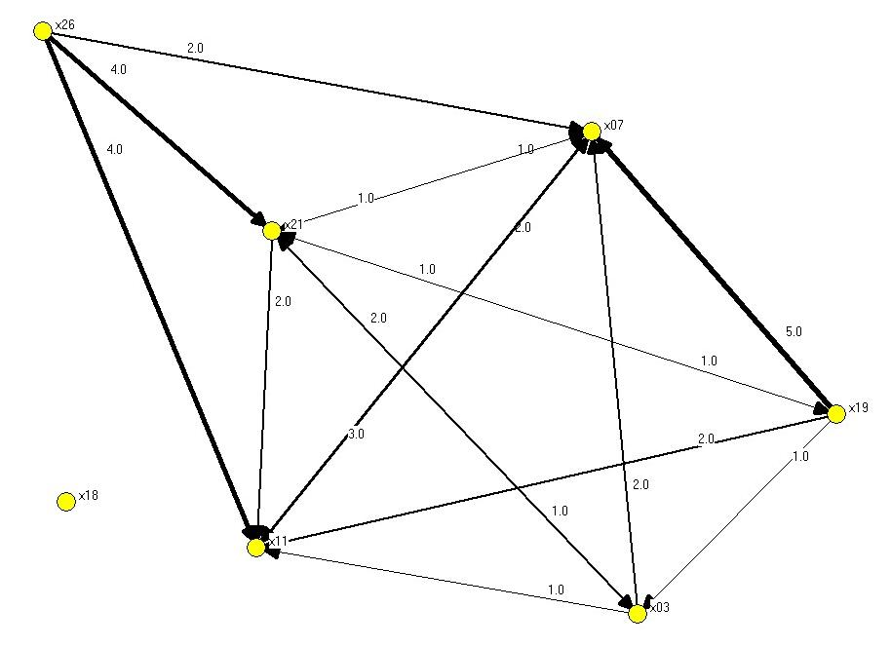
The first case we will present relates to the detection of students that do not participate in the collaborative activities. For this, we defined the student-isolated role, which is characterized by an absolute lack of interactions. In terms of the SNA indexes defined for its detection, this role is characterized by a value of zero in the C_{D}(i) indexes (indegree C_{Di}(i), and outdegree C_{Do}(i)). Besides, the students with this role appear disconnected to the rest in the sociogram, i.e., they do not have links with other actors in the network.

Figure 1. Sociogram representing an isolated student x18 within his workgroup
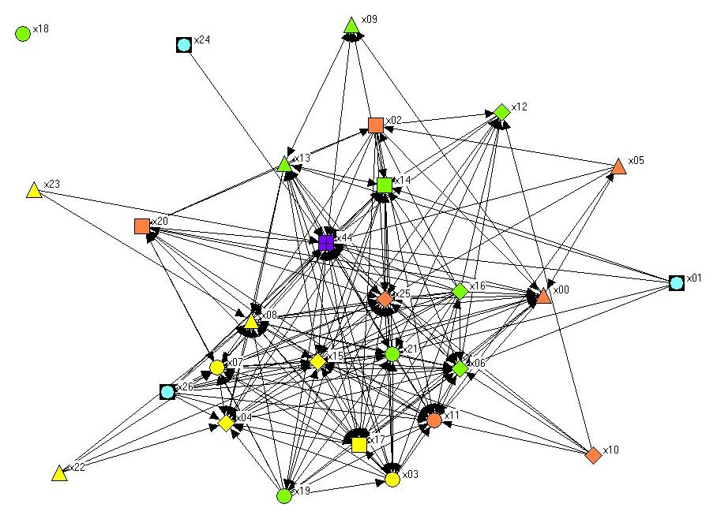
Figure 2. Sociogram representing the individual activity of all participants in the course after two weeks from the beginning of the experience. Different node shapes are used for each working group.

An analysis of the activity within the working groups defined in this course (intra-group analysis) performed by Role-AdaptIA two weeks after the beginning of the semester identified a case of student-isolated corresponding to actor x18 with C_{Di}(x18) and C_{Do}(x18) equal to zero. Figure 1 shows the sociogram associated to this intra-group analysis, where it is easy to see that node x18 is not linked with the members of his/her group.
Additionally, the analysis of the global activity of the students with respect to the rest of participants in this course during these two weeks showed the same results for this student, i.e., C_{Di}(x18)=0, and C_{Do}(x18)=0. The sociogram associated to this analysis (see Figure 2) showed clearly this fact, displaying x18 with no connections to the rest of the actors in the network.
After the identification of this role, Role-AdaptIA sent a warning to the teacher, as displayed in Figure 3. It is possible to see that the warning included information about the detection of a student-isolated role associated for student x18 into his/her group and with respect to the rest of the classroom. Besides, the warning message included the values of x18's SNA indexes as well as the two associated sociograms.
After receiving this information, the teacher interviewed x18 's group members, in order to gain insight into the conditions leading to these indexes. It was found that x18 was not attending lectures, as it was later confirmed by the observations performed by an external observer. Besides, x18 did not interact off-line with his partners through Synergeia.

Indexes of the actor x18 have changed16.10.2006

Now the actor performs this role: student - isolated

Into group indexes: with respect all participants indexes:
Indegreee: 0 Indegreee: 0
Outdegree: 0 Outdegree: 0

(A) Intra-group sociogram.

(B) All the participants sociogram

Figure 3. Warning sent to the teacher with information about the
student-isolated role detected

A new analysis performed by Role-AdaptIA showed two weeks later that the student x18 had changed his behaviour. At that moment, his indexes were C_{Di}(x18)=4, and C_{Do}(x18)=16. Although this student could not assist to lectures, he had started to work remotely, using Synergia in order to perform the collaborative tasks assigned by the teacher.
With this case we have illustrated a first example of the detection of an undesired student's role. The warning sent to the teacher by Role-AdaptIA and the intervention of the teacher allowed to modify this negative situation and to improve the collaborative activity. Although it might appear that the identification of such a student-isolated role is rather straightforward, the fact is that in this scenario it was difficult for the teacher to identify which students were not interacting at all (either face to face or remotely through Synergeia). Thus, the warning sent by Role-AdaptIA enabled the teacher's intervention and the improvement in the behaviour of the student.
3.2 Intra-group conflicts
In this case, Role-AdaptIA detected a case of intra-group isolated student. After performing an intra-group analysis, it was found that student x15 did not interact with the members of her group, i.e., her indexes were C_{Di}(x15)=0, and C_{Do}(x15)=0. Figure 4 shows the sociogram associated to this intra-group analysis, where it is easy to see that x15 appears isolated from the rest of the group, including the teacher, represented by a square.
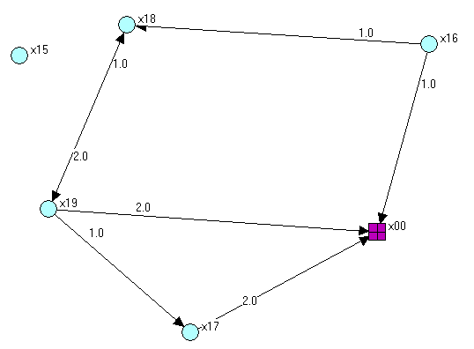

Figure 4. Sociogram representing “x15” as an isolated student within her work group

On the contrary, the general analysis of the activity of each student with respect to the rest of the classroom did not identify x15 as an isolated student, with C_{Di}(x15)=5, and C_{Do} (x15)=3. The sociogram associated to this general analysis showed that x15 was linked to four members of other groups. Figure 5 shows this sociogram.
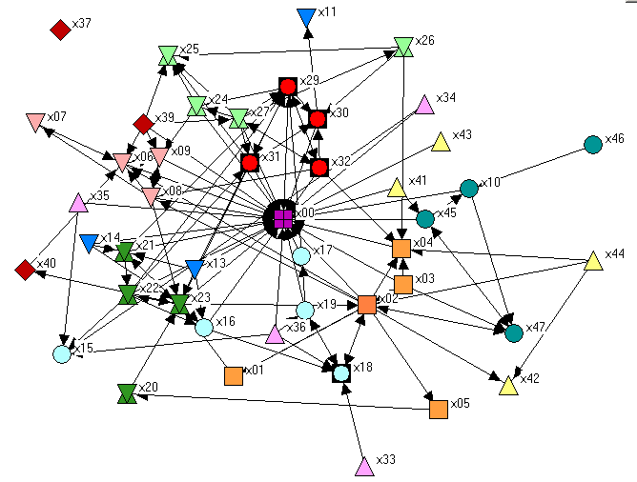
Figure 5. Sociogram representing individual activity of all participants in the course

The teacher received a warning about the detection of a student-isolated role into Group 5, together with the sociogram displayed in Figure 4, and her values C_{Di}(x15)=0, and C_{Do} (x15)=0. Besides, Role-AdaptIA sent the sociogram associated to the analysis of the individual activity (Figure 5).
A conflictive situation had been discovered, but not the reason. In contrast to the case discussed in the previous section, this student was attending lectures and participating in the activities, but, according to the information provided by Role-AdaptIA, she was not working with her group mates. The teacher interviewed the components of the group, and it was found that there was a personal conflict between two members of this group. A similar conflictive situation was detected into another group, where the student x33 did not collaborate with the members of his group. He only interacted with the student x18, a member of a third group. We can see this link between x33 and x18 in Figure 5, on the lower part of sociogram. Role-AdaptIA detected also this fact and warned the teacher about it. In order to solve the conflictive situation the teacher decided to restructure the composition of the affected groups, with a rearrange where x33 was assigned to x15's former group and vice versa.
Next analysis performed by Role-AdaptIA showed that both groups did not contain isolated students anymore. Thus, the intervention of the teacher with the support of Role-AdaptIA had been successful in reverting this negative situation.
This conflictive situation was difficult to detect on-line by the teacher, because the affected students did participate in the classroom activities, although not with their group mates, due to the mentioned personal conflicts. The high number of students in each classroom, as it is usual at university settings, makes these internal conflicts difficult to detect. In this case, Role-AdaptIA helped the teacher to detect this problem, which enabled the intervention that eventually improved the internal dynamics of the involved groups.
3.3 Group malfunctioning
In the previous cases, the detection of the negative situation (isolated students and intra-group conflicts) was based on the detection of a negative role. Additionally, Role-AdaptIA also helps to identify undesired situations hidden behind the detection of non-negative roles, as it happened in the example described in this section, where the detection of a student-coordinator role allowed identifying a group that did not collaborate properly.
A student-coordinator is defined as a student that organizes the activity into the group. He/she regularly initiates the interaction with the rest of his/her group members. Besides this, he/she maintains relationships with other groups. Table 1 shows the SNA indicators and values defined in this case by the teachers for the on-line detection of the student-coordinator role, according to the structure given by the framework.
The indicators are the ones defined in section 2. The relevance rank column states the weight of the indicator for detecting this role, specified as a priority rank (e.g., first, second). Role-AdaptIA confirms the detection of an emergent role only if all the indicators associated to a first level of relevance rank verify the specified values. This is a mandatory condition in order to validate the detection of a role-change
During the development of the collaborative activity, Role-AdaptIA detected an emergent student-coordinator role into a group (Group 8). The values of the SNA indexes of this student, es18, verified all the specifications established for this role (see Table 2) with C_{Di}=100, C_{Do}=100, C_{B}=100.
Moreover, the associated sociogram (see Figure 6) shows how the student es18 was the most centred node. These conditions indicated that es18 was a student-coordinator of this group.

Table 1. Specification of the indicators and their values for the student-coordinator role
Role: student – coordinator
Indicators | Values | Interpretation | Relevance
Outdegree C_{Do}(i) | > 75% | A very high value indicates that the student controls the work of the group members | First level
Outcloseness C_{Co}(i) | > 75% | A very high value indicates the high proximity of the student to the rest of the group members | First level
Betweenness  C_{B}(i) | > 75% | A very high value indicates good connections to the rest of the group members | First level
Actor position in sociograms | Near the center | A centered node in the graph indicates a prominent actor for the rest of participants | Second level  (for visual validation)

Additionally, it is easy to see in Figure 6 that the other group members did not present interactions among them. They only had interactions with es18. These students had the degree centrality indexes very low or zero. Besides, their degree sessions and activity values were very low. They were identified as students-semi-isolated or students-non-participatory.
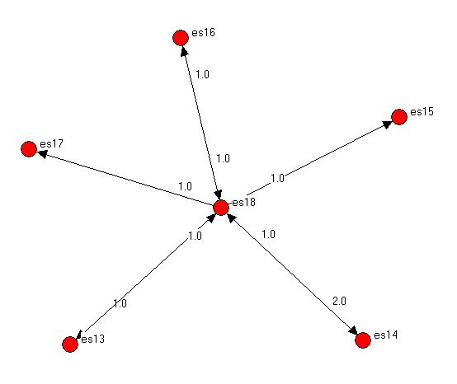

Figure 6. Sociogram representing the interactions into Group 8. The centered
node, “es18”, was the student-coordinator role detected

The teacher received warnings about these role detections together with the values of the related SNA indicators for this group and the associated sociogram. This information suggested abnormal collaboration.
In order to understand better this group's behaviour, the teacher interviewed the group members and reviewed the detailed information elaborated by Role-AdaptIA about the interactions into this group. The conclusion was that the students of Group 8 did not work collaboratively. They cooperated in order to elaborate the report associated to the collaborative task dividing it into five parts. Each student elaborated one of them and later, es18, put together all the fragments, creating a final report. For this aim, es18 read documents coming from the rest of the members (each part of the report), and some of these members read the final report created by es18. Even the students es15 and es17 did not read the final report “elaborated” by their group.
In order to improve collaboration in this group, the teacher dialogued with the group members in the classroom. The teacher explained the collaboration concept again and clarified why the work performed by Group 8 was not real collaboration.
Next analysis performed by the IA tool allowed to verify how the intervention of the teacher helped to improve the intra-group collaboration. During the next task, i.e., the elaboration of the second report in the practical phase (see section 3.1) the analysis showed the evolution of the interactions into Group 8. Figure 7 shows the sociogram associated to this task. We can see that all the members are linked with several partners (three, four or five), that is, they have interactions among them.
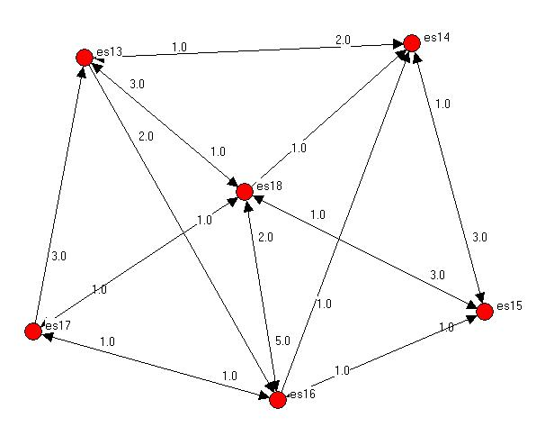

Figure 7. Sociogram representing the evolution of the interactions into Group 8.

The undesired situation presented in this section probably would have gone unnoticed on-line by the teacher. The warning sent by Role-AdaptIA and the information attached was fundamental in order to detect a group that did not collaborate properly, and the teacher’s intervention achieved to improve the collaborative activity into the group.
3.4 Teacher dependent students
The three negative situations shown above were based on the detection of a student-role change identified by Role-AdaptIA. In this section, we present an undesired collaborative situation based on the analysis of the teacher role changes. In this case, the initial detection of a teacher-guide role and the evolution towards a teacher-collaborator role helped to identify students that were totally dependent on the teacher’s interventions and suggestions. These students did not improve their autonomy during the collaborative experience.
The analysis of the teacher’s activity during the development of the tasks detected a role change. Initially, during the elaboration of the first report by the students, i.e., in the theoretical phase, a teacher-guide role was detected. According to the SNA indexes, she conducted the activity and her contributions were the most relevant for the students. Her indegree and incloseness were the highest of participants (29 and 10.57 respectively) and she was the most centred node in the sociogram. This was expected by the teacher, because the students had not previous experience with collaborative work and tools.
Just as it was also expected, the teacher’s relevance decreased during the next weeks. Thus, after the first part of the practical phase Role-AdaptIA detected that the teacher had lost her role of a guide and she had become a collaborator. More than 50% of students presented higher values in their SNA indexes (with C_{Di} values ranging from 132.00 to 21.00 and C_{Ci} values from 10.39 to 8.82, while the teacher’s values of these indexes were C_{Di}(teacher)=14.00 and C_{Ci}(teacher)=8.77, respectively), and her position in the sociogram was not centred anymore. These indicators reflected that the teacher was monitoring the activity but only participating at specific moments, for example for reading the reports elaborated by students in the theoretical phase.
The evolution detected on the teacher’s role indicated that the students needed more the teacher’s interventions at the beginning of the activity, because they did not know the subject and they had no previous experience with collaborative tools and tasks. Later, the students had reached certain autonomy and they could work more independently. At that moment was when the teacher-collaborator role emerged.
However, the intra-groups analysis performed by Role-AdaptIA indicated that the teacher behaved still as a leader for some groups. Then, the teacher received two types of warnings by Role-AdaptIA. On the one hand, Role-AdaptIA sent information about the groups where the teacher evolutioned to as a teacher- collaborator role. For example, Figure 8 shows the sociogram sent to the teacher associated to Group 2’s activity during the first part of the practical phase. We can observe that the teacher, represented by a square node was not a centred node anymore. Moreover, the relationships among the members of the group do not vary if the teacher’s node is excluded of the sociogram. The members of this group did not depend on the teacher on their workgroup.
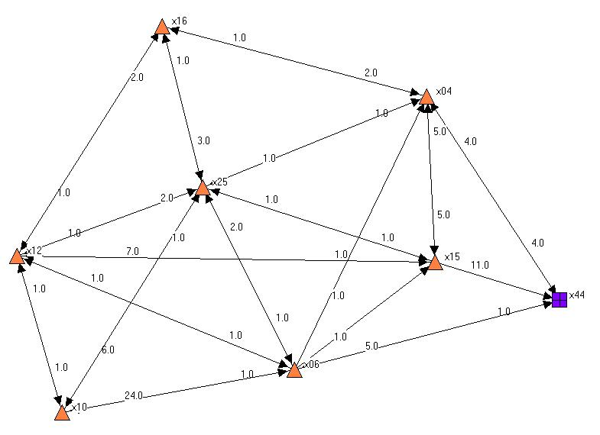
Figure 8. Sociogram representing the intra-group activity of Group 2 during the first
part of practical phase, including the teacher, represented by a squared node

On the other hand, Role-AdaptIA sent to the teacher information about the groups where she maintained the teacher-guide role. For example, Figure 9 shows the sociogram associated to Group 3's activity during the first part of the practical phase. We can observe that the teacher is the more centred node in the sociogram. The majority of Group 3’s members were linked to the teacher, and they had very few links among them.
Figure 10 shows the activity of this group during the same period excluding the teacher. It shows a disconnected group, where each student is linked only to one or two other group members. This meant that the students were totally dependent of teacher’s contributions in order to achieve a good collaboration, but they did not work collaboratively among them.

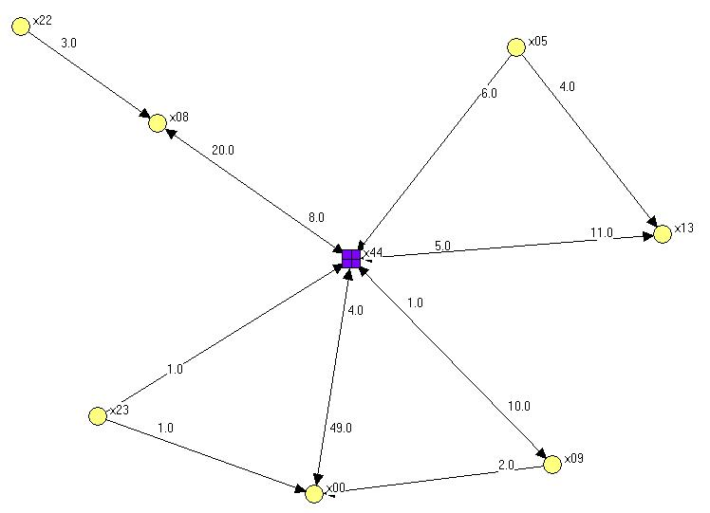
Figure 9. Sociogram representing the intra-group activity of Group 3 during the first
part of practical phase, including the teacher, represented by a squared node.

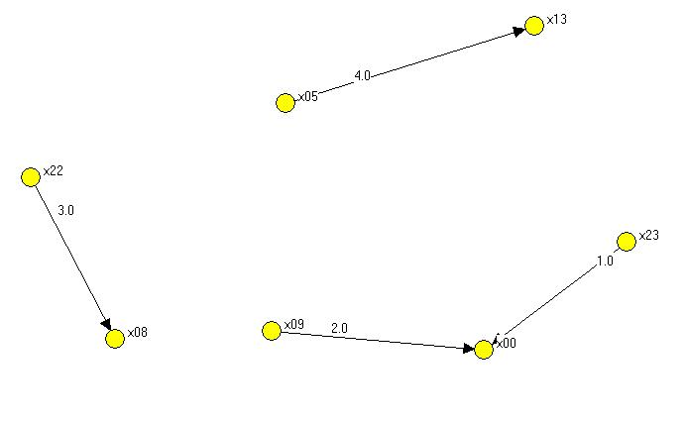
The teacher intervened discussing with these students about the lack of collaborative activity found in their group. She encouraged the students to increase this activity. A later analysis performed by Role-AdaptIA in this course allowed to verify that the teacher had lost her role of a guide in this group at the end of the practical phase, i.e., she had succeed in promoting the group's internal collaboration.
Figure 10. Sociogram representing the intra-group activity of Group 3 (excluding
the teacher), during the first part of practical phase

The undesired situation presented in this section was detected by analysing the expected evolution of the teacher’s role from guide to collaborator. This evolution implied that the experience acquired by the students during the first phase of the course would allow them to achieve a certain autonomy with respect to the teacher during the following phases. The analysis of the groups where this evolution had not happen allowed to detect which students were still too dependant on the teacher's contributions. Then, she could intervene in order to face this lack of autonomy.
4. Conclusions and further work
IA methods and tools can help to regulate CSCL activities providing adequate feedback to the participants. IA helps to compare the actual collaboration state with respect to the planned before the beginning of the activity. Then, the teachers can intervene for recommending actions to the participants in order to improve the collaborative process.
This work has presented four negative situations identified in a real CSCL scenario using an approach based on the detection of role changes during the development of collaborative learning activities. Our approach uses a theoretical framework for the description of roles in CSCL scenarios, supported by an adaptive IA tool called Role-AdaptIA. With the structured description of roles given by the framework, Role-AdaptIA is able to adapt its output to the roles emerging during a collaborative learning activity, and this way, it helps to regulate collaboration in the classroom.
In the cases described in this work, the process for the detection of negative situations began with the identification by Role-AdaptIA of a role change during the collaborative activity. Then, Role-AdaptIA sent a warning to the teacher advising about the new role detected. Besides, the teacher received SNA information (numerical and graphical) associated to this role change. This information helped the teacher, either directly or indirectly, to discover negative collaboration situations. On the one hand, some negative roles, such as the student-isolated, allowed to identify undesired collaboration situations. On the other hand, some roles not considered as negative in principle, covered conflictive or negative situations, such as the student-coordinator role case. The detection of this role helped to detect a workgroup that was not collaborating properly. Finally, Role-AdaptIA also supported the identification of other negative situations by the analysis of the teacher's role changes. In all these cases, the warnings received by teachers and their later interventions achieved to solve these negative situations, and eventually, to improve the collaborative activities. It is important to note that without the support provided by Role-AdaptIA most of these situation would have went unnoticed by the teacher.
Upcoming work plans point to incrementing the number of roles to identify by Role-AdaptIA as well as to extend the tool functionality to allow the teacher new and finer types of analysis. Overall, these aspects are meant to contribute to improve the regulation of computer-supported collaborative learning activities in real practice.

Acknowledgments This work has been partially funded by the Spanish Ministry of Education and Science (TSI-2005-08225-C07-04) and the Autonomous Government of Castilla y León, Spain (projects VA107A08 and VA106A08). The authors would like to thank the rest of GSIC/EMIC group at the University of Valladolid for their support and ideas.
References
- Koschmann, T. "Paradigms shift and instructional technology", in CSCL: Theory and practice of an emerging paradigm, T. Koschmann (ed.), Lawrence Erlbaum Associates, Mahwah, NJ, USA, 1996, pp. 1-23.
- Dillenbourg, P. (1999). Introduction; What do you mean by “Collaborative Learning”? P.Dillenbourg (Ed.), Collaborative Learning. Cognitive and Computational Approaches (p. 1-19). Oxford: Elsevier Science Ltd.
- Jermann, P., Soller, A., & Lesgold, A. “Computer software support for CSCL”. In P. Dillenbourg (Series Ed) & J.W.Strijbos, P.A.Kirschner & R.L.Martens (Vol. Eds.), Computer-supported collaborative learning: vol 3. What we know about CSCL… and implementing it in higher education (pp. 141-166). Boston, MA:Kluwer Academic Publishers. (2004)
- Edwards, W.K. “Policies and Roles in Collaborative Applications”, in Proceedings of the 1996 ACM Conference on CSCW. ACM Press, 1996. pp- 11-20
- Soller, A., Martínez, A., Jermann, P., and Muehlenbrock, M. "From Mirroring to Guiding: A Review of the State of the Art Technology for Supporting Collaborative Learning", International Journal on Artiﬁcial Intelligence in Education (15), 2005, pp. 261-290
- Marcos-Garcia, J., Martínez-Monés, A., Dimitriadis, Y. and Anguita-Martinez, R., (2007) "A role-based approach for the support of collaborative learning activities", e-Services Journal. 6(1).
- Marcos-García, J.A., Martínez-Monés, A., Dimitriadis, Y and Rodríguez-Triana, M.J. “Role-AdaptIA: A role-based adaptive tool for interaction analysis”. ICLS workshop. June, 23-24, 2008. Utrecht, The Netherlands.
- Wasserman, S. & Faust K. Social Network Analysis: Methods and Applications. Cambridge University Press., Cambridge (1994).
- Wenger, E. “Communities of practice. Learning, meaning and identity. Cambridge, U.K. Cambridge University Press
- Sfard, A. “On two metaphors for learning and the dangers of choosing just one”. Educational Researcher, 27, 1998. pp.4-13
- Scott, J. “Social Network Analysis: A handbook”. 2nd ed. Thousands Oaks, California. Sage Publications, 2000
- Marcos, J.A., Martínez, A., Dimitriadis, Y., Anguita, R. “Adapting interaction analysis to support evaluation an regulation: a case study”. Proceedings of the 6th International Conference on Advanced Learning Technologies, ICALT 2006. pp 125-129, Kerkrade, The Netherlands, July 2006
- Marcos, J.A., Martínez, A., and Dimitriadis, Y. "Interaction Analysis for the Detection and Support of Participatory Roles in CSCL", in Proceedings of the 12th International Workshop on Groupware, Springer Verlag, 2006, pp. 155-162
- Martínez, A., Dimitriadis, Y., Tardajos, J., Velloso, O. and Villacorta, M. “Integration of SNA in a mixed evaluation approach for the study of participatory aspects of collaboration”. In European Conference on Computer Supported Collaborative Work (ECSCW03), workshop on Social Networks. Helsinki, Finland, 2003.
- ITCOLE Research Project. “About Synergeia”. Retrieved November 2008 from http://bscl.gmd.de

